**DAILY ONLINE ACTIVITIES SUMMARY**

|  |  |  |  |
| --- | --- | --- | --- |
| **Date:** | 4/07/2020 | **Name:** | JASLINE SHARON TAURO |
| **Sem & Sec** | 4th sem,  A Section | **USN:** | 4AL18CS029 |
| **Online Test Summary** | | | |
| **Subject** | NA | | |
| **Max. Marks** | NA | **Score** | NA |
| **Certification Course Summary** | | | |
| **Course** | Cloud Support Associate | | |
| **Certificate Provider** | AWS Educate | **Duration:** | 4 hrs |
| **Coding Challenges** | | | |
| **Problem Statement:**  Given an array of integer arr[] and an integer k, the task is to find the median of each window of size k starting from the left and moving towards the right by one position each time. | | | |
| **Status:** Executed | | | |
| **Uploaded the report in GitHub** | | YES | |
| **If yes Repository name** | | <https://github.com/jaslinesharontauro/JAVA_Prgms> | |
| **Uploaded the report in slack** | | YES | |

**Certification Course Details:**

Today I continued the course “Cloud Support Associate” by AWS Educate. In this course today I learnt about ‘Network’ and ‘General concepts of Software Development’. Today I have completed assessment of the module Network.

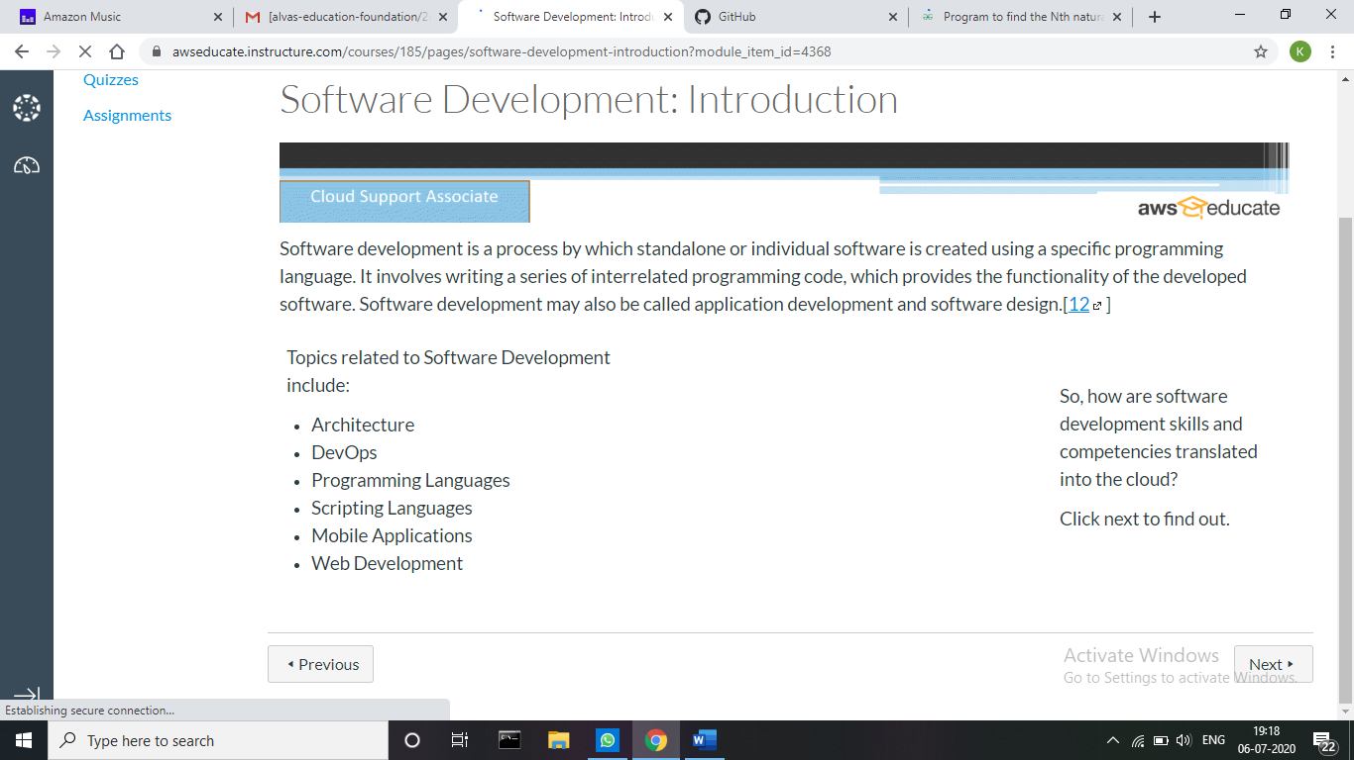



**Webinar Details:**

Today I attended a webinar on “Advanced IT requirements for future Engineers” by Mr. Aditya Naik, Site Core Developer, Valtech, Bangalore. The session was very interesting.

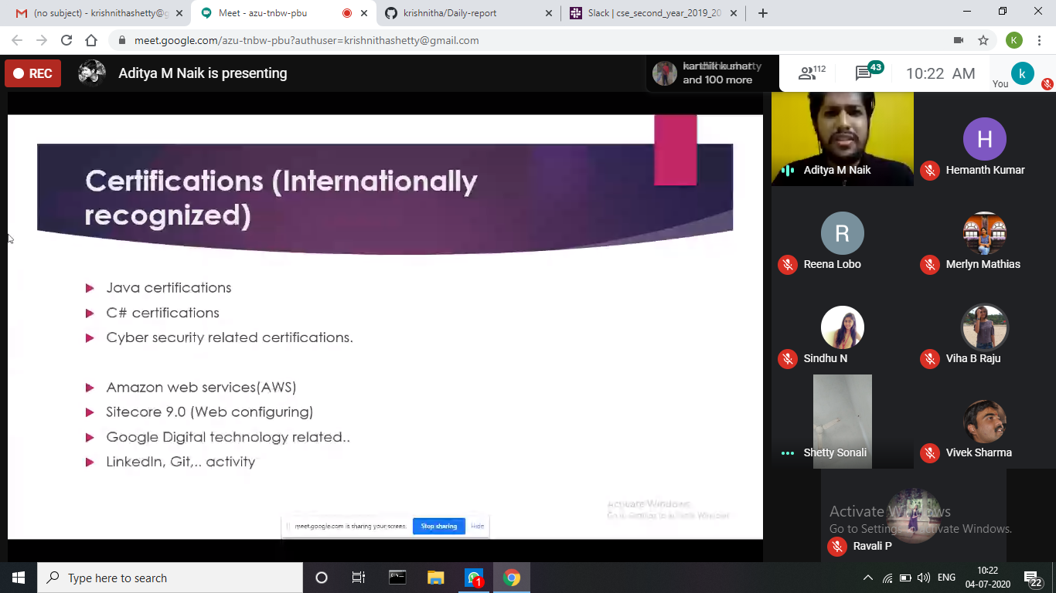

**Coding Challenges Details:**

**Problem:** Given an array of integer arr[] and an integer k, the task is to find the median of each window of size k starting from the left and moving towards the right by one position each time.

**Examples:**

Input: arr[] = {-1, 5, 13, 8, 2, 3, 3, 1}, k = 3

Output: 5 8 8 3 3 3

Input: arr[] = {-1, 5, 13, 8, 2, 3, 3, 1}, k = 4

Output: 6.5 6.5 5.5 3.0 2.5

**Solution:** Uploaded it in GitHub

